**Plate Cleanliness Detection Report**

UWB CSS 487, Professor Clark Olsen | By: Fang Wu and Stanley Hsieh

**Initial Plan 1**

**What We Accomplished 1**

Plate Detection 2

White Plate Cleanliness Detection 2

Pattern Plate Cleanliness Detection 3

**Conclusion 3**

Strengths 3

Weaknesses 3

Reflection 4

# **Initial Plan**

Our initial plan was to create a program that could detect cats in a photo. We ran into issues where we could not accurately detect cats in our image. We initially tried to detect the image for pointed ears, but for obvious reasons this did not work. A cat's ears are not always pointed and could falsely detect any triangular object as an ear. So we decided to switch to plate detection as we could clearly think through the process and how to execute it.

Our project first needs to be able to recognize plates in an image, then we need to be able draw a box around the box and label the plate.

After the plates are located we need to be able to identify the patterns on a plate, so we identify if a plate is a white plate or a patterned plate.

Next we wanted to be able to determine if the plates were clean or dirty.

Lastly if time permits we also wanted to be able to detect utensils, box them and label them like the plates.

# 

# **What We Accomplished**

We created a program that can detect plates in images and determine the type of plate and if the plate was dirty or clean. The program was created in C++ in addition to the OpenCV Library.

We were able to accomplish almost everything we planned on. We completed the plate detection, labeling, and classification of dirty or clean plates.

There were some bugs with our pattern plate cleanliness detections in some cases, but most of our tests passed.

We did not have enough time to create utensil detection.

**Results**

## Plate Detection

| White Plate | Patterned Plates |
| --- | --- |

## 

## 

## White Plate Cleanliness Detection

## 

## Pattern Plate Cleanliness Detection

| Clean | Dirty |
| --- | --- |

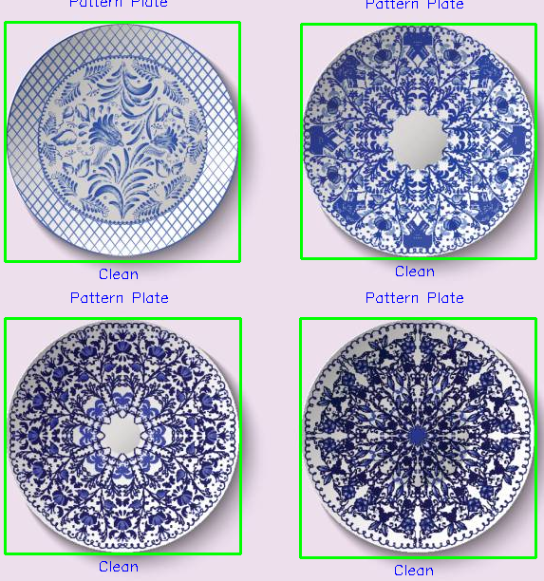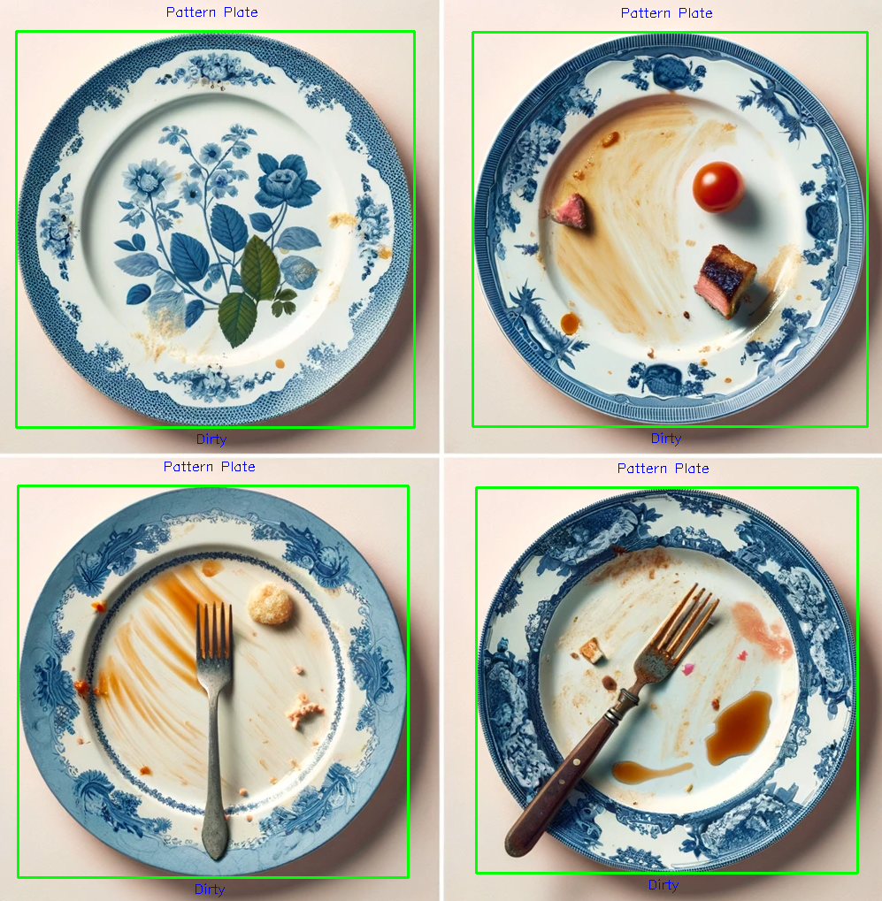

# 

# 

# 

# 

# 

# 

# 

# 

# **Conclusion**

## Strengths

* Classifying clean and dirty white plates using white percentage and process of elimination.
* Our program does a good job detecting circular shapes very well.

## Weaknesses

* Our program struggles to distinguish between other circular objects and classify them as plates.
* Patterned plates cleanliness only works if the image only contains dirty or clean plates and not both.

## Reflection

We learned that computer vision is very hard, the math prerequisites are no joke. We also learned that because we are new to computer vision our first idea of how to do something will probably not work. While coding we got a better understanding of how to use SIFT to detect more complex items. It made it a lot easier to distinguish the pattern plates. We also got practice using many different methods of image processing, such as dilate, different color scales, blurring, HSV filters, and masks. We learned how to more efficiently use these processing methods to meet our needs.

# 